University of South Florida

CDA 4205L Computer Architecture Lab

Lab Report

Semester: Fall 2023
Experiment | Number: | 5
Experiment | Date: | 09/28/2023
Lab | Section: | 001
Lab | Lab TA: | Benjamin Krieger
Report | Due Date: | 10/05/2023
Group  (Lab3 onwards) | Member #1 name: | Diya Jain
Group  (Lab3 onwards) | Member #2 name: | Suraj Kumar

ABSTRACT:
The goal of this lab is to help us understand how floating-point arithmetic instructions work and how they are used in a RISC-V assembly program. We worked in RARS to write a program in RISC-V where we implemented different ways of taking the square root of a floating-point value. We used the built-in square root function and the Newton-Raphson method to get the square root without using square root instructions.

INTRODUCTION:
In this lab, we will convert binary value to floating point value (single and double) binary string by using some special instructions. To be detailed, we will convert the value into a single-precision/double-precision. We then perform the square root operation and then square that result to return to the original number. Next, we will try to get the results without using any implementation we did at the previous stage. The Newton-Raphson method will be applied to be able to find the value.

METHOD:

Software Tools Used:
- rars.jar

Files:
- nr-method-template.asm (The final file containing the code to get the square root by using special instructions and the Newton-Raphson method).

RESULTS:

T1: You may expect the result of square(sqrt(value)) to return the original, however
this may not always be the case in practice. Why?

The reason can be there is some loss of precision in floating point arithmetic so the results might be slightly different from the expected output. For example, in the picture below, we can see the double-precision printout ‘107799.99999999999’ instead of ‘107800.0’. Besides, there are a lot of values that don’t have the perfect square root or some special values that we can use floating point methods to represent (negative values).

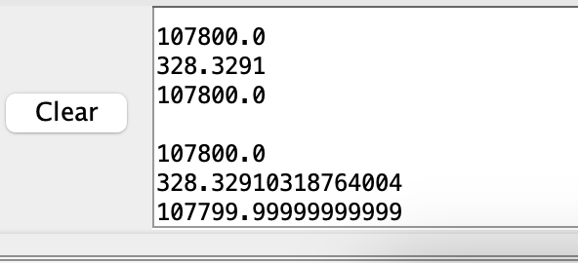

T2: Include a table showing the original value, the “guess” after 3, 5, 7, and 9 iterations, and the error compared to the output of fsqrt.d (which you computed in step 2d).

3 iterations:
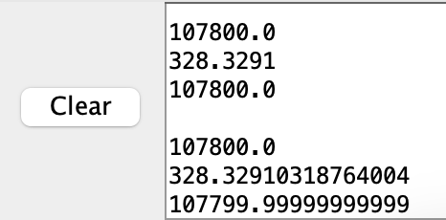
5 iterations:
7 iterations:
9 iterations:

T3: Pick a number between 10⁵ and 10⁶ and run your code while varying the threshold from 10⁻¹ to 10⁻⁸. Include a table that shows how many iterations it took before the loop exits for each of the 8 thresholds.

For Threshold 10⁻¹:
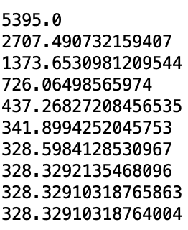

For Threshold 10⁻²:

For Threshold 10⁻³:

For threshold 10⁻⁴, 10⁻⁵, 10⁻⁶, 10⁻⁷, 10⁻⁸ respectively:

Threshold Value | Total number of iterations
10⁻¹ | 9
10⁻² | 9
10⁻³ | 9
10⁻⁴ | 9
10⁻⁵ | 9
10⁻⁶ | 9
10⁻⁷ | 9
10⁻⁸ | 9

DISCUSSION:
A template assembly file for printing floats, doubles, and other operations initiates the lab. First, we put a non-perfect square value into the t0 register. Then, the fa0 register stores the value in single-precision floating point format. Printing the converted value verifies accuracy. The converted value is squared using the square root instruction. The specialized instruction's precision compared to the Newton-Raphson approximation is printed. To check its accuracy, the square root is multiplied by itself and printed again. Then we repeated the process with a double-precision floating point value. After converting the double-precision number, square root it, then output the squared result. This lets us compare single-precision and double-precision accuracy.

CONCLUSION:
The lab investigates the Newton-Raphson method for computing square roots in RISC-V assembly programming. By comparing the results of the Newton-Raphson method to those of dedicated square root instructions, it is possible to gain insight into the accuracy and efficacy of the numerical approximation method. The laboratory exercises reinforce the understanding of the Newton-Raphson method as a general technique for finding roots of functions and its application in computing square roots. In addition, it gave us hands-on experience with RISC-V assembly programming and floating-point operations.

